**Assignment 2 Output**

Name: Vedant Vichare

Roll No. : 35

Prn: 1032222186

Panel :B

DDL Commands: -

Exercise-1

Output

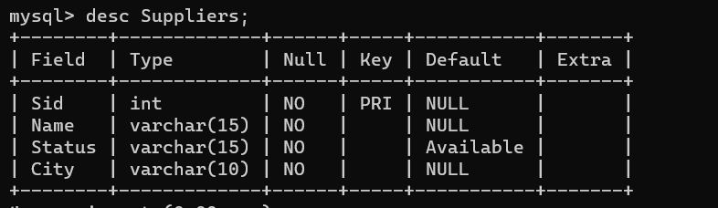

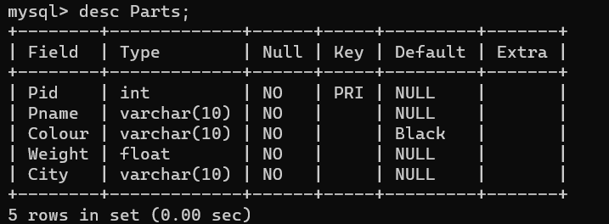

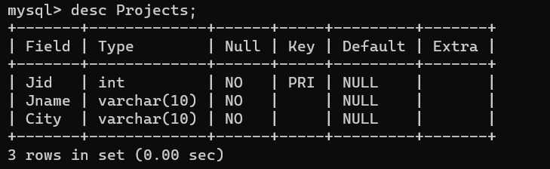

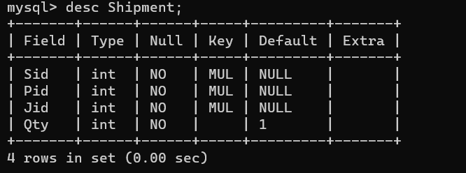

Alter Commands

Output

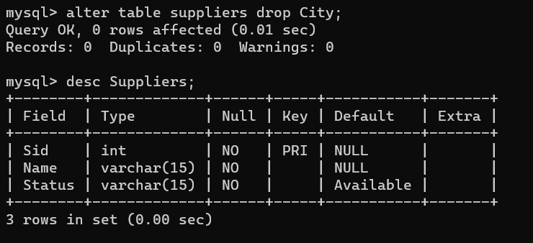

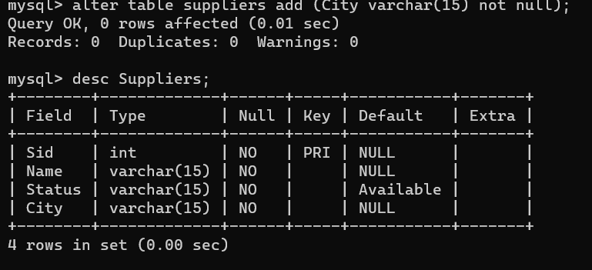

Exercise 2

DCL COMMANDS

Output

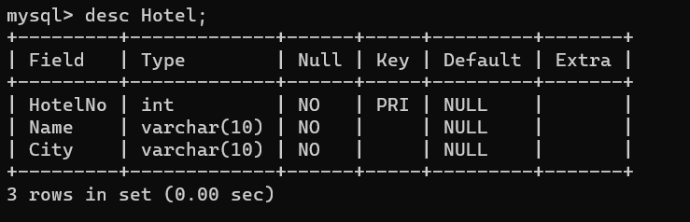

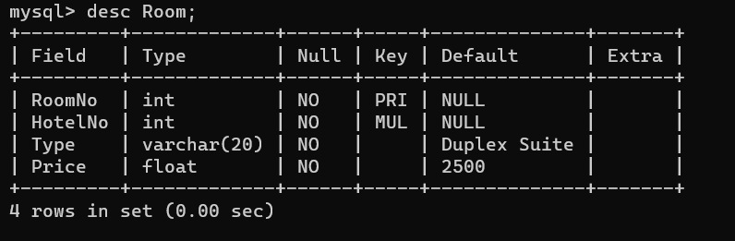

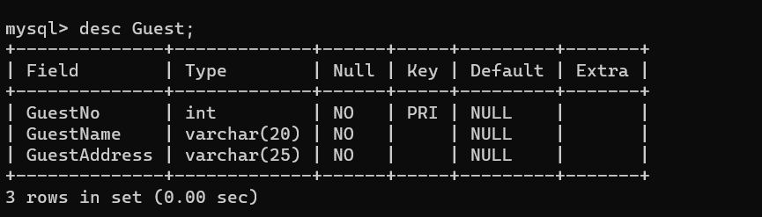

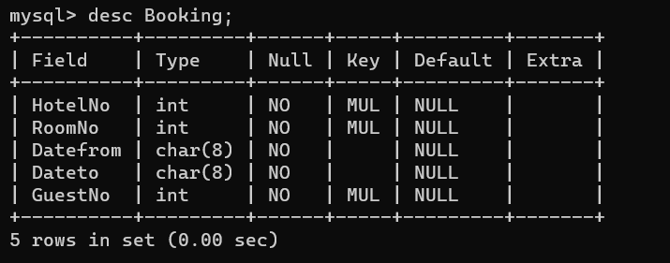

DCL COMMANDS

Output

mysql> select user from mysql.user;

+------------------+

| user |

+------------------+

| adeeb |

| adi22 |

| kaushik1 |

| mysql.infoschema |

| mysql.session |

| mysql.sys |

| root |

| tanvi |

+------------------+

8 rows in set (0.00 sec)

mysql> select user from mysql.user

-> ;

+------------------+

| user |

+------------------+

| sample@localhost |

| adeeb |

| adi22 |

| kaushik1 |

| mysql.infoschema |

| mysql.session |

| mysql.sys |

| root |

| sample |

| tanvi |

+------------------+

10 rows in set (0.00 sec)

mysql> show grants for 'sample '@' localhost';

+--------------------------------------------+

| Grants for sample@localhost |

+--------------------------------------------+

| GRANT USAGE ON *.* TO `sample`@`localhost` |

+--------------------------------------------+

1 row in set (0.00 sec)

mysql> show grants for 'sample '@' localhost';

+-------------------------------------------------------------+

| Grants for sample@localhost |

+-------------------------------------------------------------+

| GRANT USAGE ON *.* TO `sample`@`localhost` |

| GRANT INSERT ON `vedant`.`student` TO `sample`@`localhost` |

+-------------------------------------------------------------+

2 rows in set (0.00 sec)

mysql> show grants for 'sample '@' localhost';

+---------------------------------------------------------------------+

| Grants for sample@localhost |

+---------------------------------------------------------------------+

| GRANT USAGE ON *.* TO `sample`@`localhost` |

| GRANT SELECT, INSERT ON `vedant`.`student` TO `sample`@`localhost` |

+---------------------------------------------------------------------+

2 rows in set (0.00 sec)

mysql> show grants for 'sample '@' localhost';

+-------------------------------------------------------------+

| Grants for sample@localhost |

+-------------------------------------------------------------+

| GRANT USAGE ON *.* TO `sample`@`localhost` |

| GRANT INSERT ON `vedant`.`student` TO `sample`@`localhost` |

+-------------------------------------------------------------+

2 rows in set (0.00 sec)

mysql> show databases;

+--------------------+

| Database |

+--------------------+

| vedant |

| information_schema |

| performance_schema |

+--------------------+

3 rows in set (0.01 sec)

mysql> select * from student;

+------+---------+

| id | name |

+------+---------+

| 1 | vedant |

| 2 | manish |

+------+---------+

2 rows in set (0.00 sec)